Wireframe

**Login Page**

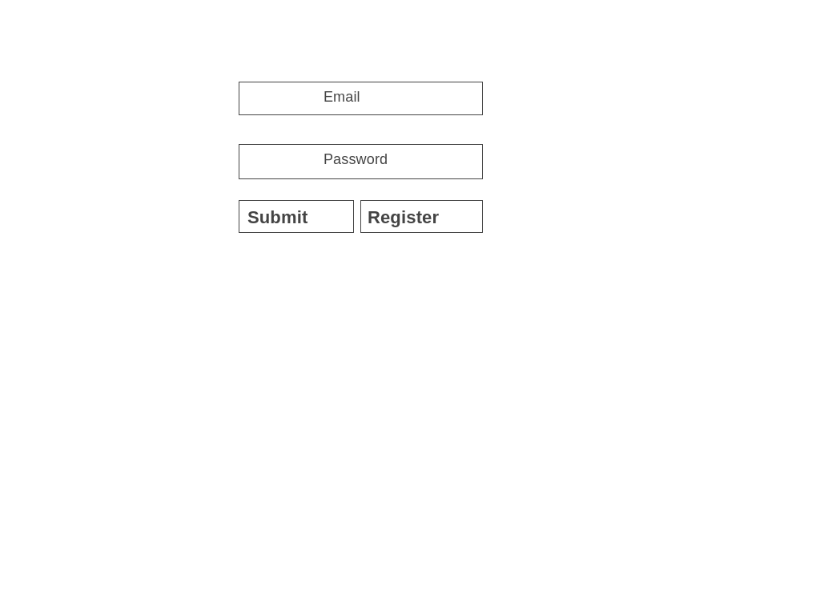

**Register Page**

**Home Page**

**View Car Details**

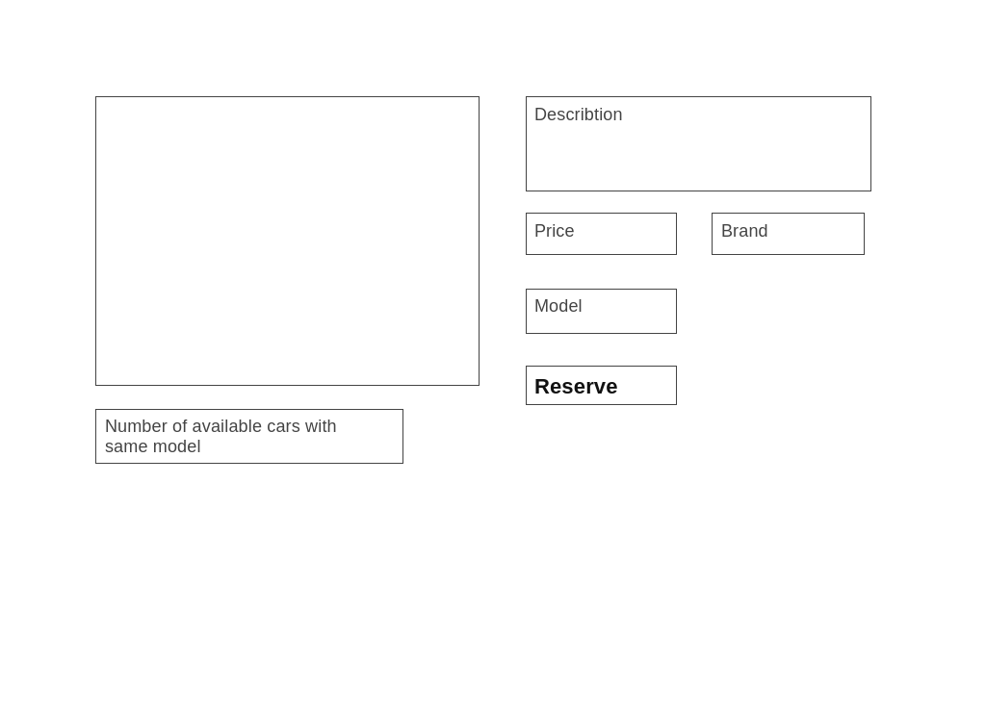

**Reserve Page**

**Admin-Home Page**

**Admin-Add Car**

**Admin-All Cars Page**

**Admin-Post-Delete Page**

